实验7使用Jupiter进行代码审查

|  |  |  |  |  |  |  |  |
| --- | --- | --- | --- | --- | --- | --- | --- |
| 组 别 |  | 实验人员 | KAFLE SAMRAT | | | | |
| 实验项目名称 | 使用Jupiter进行代码审查 | | | | | | |
| 实 验 类 别 | 验证型□ 设计型□ 综合型□ | | | | | | |
| 实 验 工 具 | Eclipse | | | 实验地点 | J13-132 | 实验日期 | 2020.12.21 |
| 学生实验小结 | 利用Jupiter的代码审查review功能进行代码审查修改，让我感受到了Jupiter的便捷之处，利用它我可以个人查找错误，然后团队决定如何处理错误，最后通过编写人对错误进行修改，环节层层衔接和记录，使得整个审查工作流畅，效率很高。 | | | | | | |
| 教师评语 | 指导教师签名：  年 月 日 | | | | | | |
| 实验成绩 |  | | | | | | |

1实验内容和目标

1.1实验内容

基于实验一《Jupiter的安装及Review ID的创建及发布》的工作，通过获取.jupiter文件，进行Individual Phase、Team Phase及Rework Phase三个阶段的审查工作。

1.2实验目标

了解Individual Phase、Team Phase以及Rework Phase三个阶段的目标，并熟练掌握上述三个阶段的操作过程。

2实验方案设计

2.1实验环境

Eclipse+jdk1.8

2.2实验方法设计

使用eclipse里的review功能，实现对存在问题的工程代码进行审查

3实验步骤和结果

1: Individual Phase

(1) Update or get the.jupiter file in the version controller or email and put it in the file path of the project to be reviewed (the same directory as the SRC folder)

(2) Click the drop-down arrow of the Jupiter plug-in icon in the Eclipse toolbar and select the option of "1 Individual Phase" to enter the personal review Phase;

(3) In the pop-up "Review ID Selection" dialog box, select "Project Name", "Review ID" and "Reviewer ID", as shown in Figure 2. After completion, click "Finish" to complete the Selection. At this time, a folder (as shown in Figure 3) will be generated under the Project to be reviewed in the "Project Explorer" list, which is used to store the xxx.review.

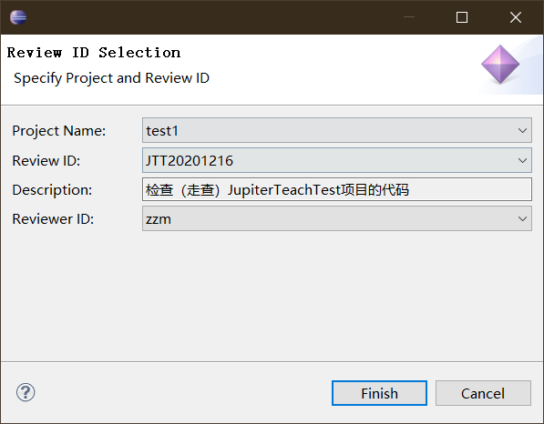

(4) After the completion of Step (3), start the formal personal Review of the code, Review the code to be checked, and when bugs are found, select the code with bugs (on the line) and right-click "Add Review Issue..." .

(5) Describe the bug in the Individual Phase TAB of the Review Editor, save it, and find a blue mark on the left side of the line of code.

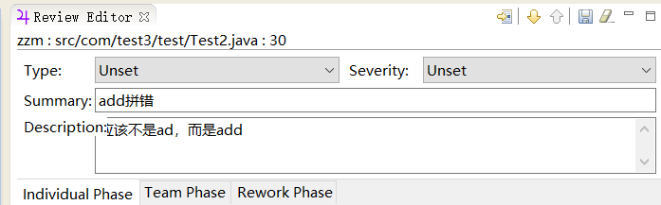

(6) Repeat the operation of step (5) until the bug can no longer be found. The result is a list of records in the "Review Table".

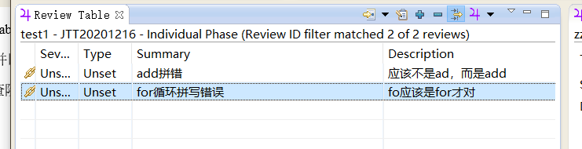

(7) Submit the review document to the version control system, and reply to the review sponsor that your task has been completed, and send the review document together with the review sponsor. The individual review stage is now over.

3.2 Team Phase

(1) Enter the "Team Phase", and the specific operation is similar to Step (2) in Task 1;

(2) Select "Project Name", "Review ID" and "Reviewer ID" in the pop-up "Review ID Selection" dialog box to determine which Reviewer to discuss the issue reviewed, and then click "Finish" to enter the bug browsing interface;

(3) By double-clicking each record, you can directly navigate To the code statement with a bug, and display the specific description of the bug in the "Review Editor". After the team gets the opinions on how To deal with the bug, fill in "Assigned To" (Assigned), "Resolution" (solution) and "Annotation" (specific description of the solution), and then save it.

(4) The review team repeats Step (3) until all bug records have been discussed.

(5) At this point, the main work of team review has been completed. Review file should be submitted to version controller and code modification personnel should be notified for modification.

Task 3 Rework Phase

(1) Enter the "Rework Phase", and the specific operation is similar to Step (2) in the experimental task 1;

(2) Select "Project Name", "Review ID" and "Reviewer ID" in the "Review ID Selection" dialog box that pops up, where "Reviewer ID" represents the code modifier (i.e., select your ID), and click "Finish" to enter the bug browsing interface, i.e. "Review Table" as shown in Figure 7;



(3) Double-click the bug record, you can navigate to the code where the bug is, and there are code description and modification comments in the "Review Editor". After modifying the code, adjust the information in the "Review Editor"

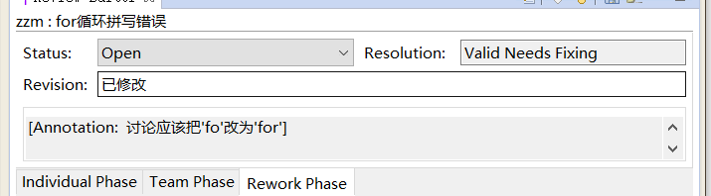

(4) Repeat the work in Step (3) until all bugs are fixed.

(5) After that, the. Review file is released to the version controller and the code reviewer is informed that the bug has been modified and fixed.

(6) If code and bug modification need to be reviewed, code reviewers need to enter the "Rework Phase" again to check the modification of bugs and adjust the status of bugs.

4实验结果分析

The Individual Phase is an Individual review. The target is the point of departure from which the reviewer specified during the ReviewID definition phase should start work, complete his or her tasks, and submit them to the version controller, many of the details that need to be noted below.

The Team Phase is going through the Team Phase. The goal is to bring together the review documents of many reviewers and then have a review meeting to discuss the issues and determine if they need to be adjusted or if they need to be addressed by someone.

The Rework Phase is a Phase of fixing bugs. The goal was that each developer would look at the checked bug and fix it thoroughly, leaving no opportunity for the reviewer to Reopen.